Spark SQL: Creating a Hive table using Spark SQL

- Create a cluster
- Enter the name of your cluster, select DataBricks run time version and click create cluster
- Click Event log and verify the cluster status
- Create new Scala notebook
- Create an instance of Hive Context:
- Create a hive table person1 with first_name, last_name,and age as columns

- Upload the sample.txt file. Click  in the left pane and navigate to createtable or you can navigate to Fileupload in the Scala notebook screen to upload the file into tables folder.
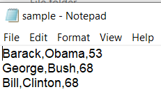
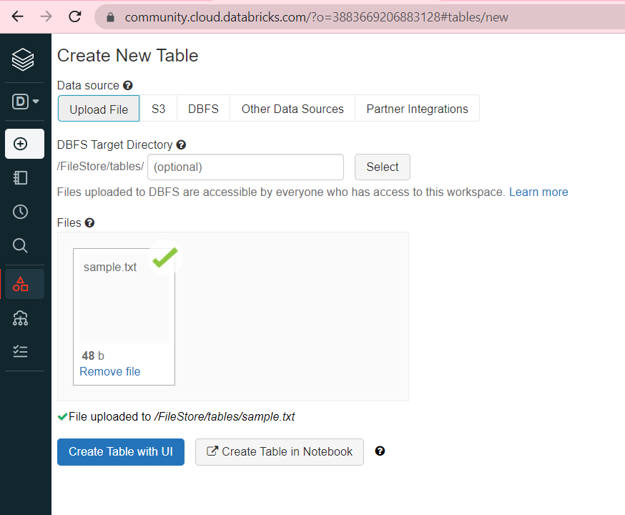
- Load the data into person1 table
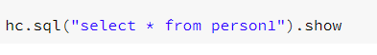
- Select the person1 data using HiveQL

- Create a new table from the output of select query

